EXPT NO:1 | Implementation of data charts
DATE: 06.01.2026 | Implementation of data charts

PRE-LAB QUESTIONS (Brief Answers)
- Visualization & student outcomes
Helps quickly identify weak subjects, performance gaps, and learning trends for timely intervention.
- Charts for subject-wise comparison
Bar charts and grouped bar charts.
- Data scale for student marks
Ratio scale.
- Need for data cleaning
To remove errors, missing values, and inconsistencies that can mislead analysis.
- Visualization & evidence-based decisions
Converts raw data into insights that support objective academic planning.

IN-LAB EXERCISE:
OBJECTIVE:
To design appropriate data charts to analyze and compare academic performance indicators.
SCENARIO:
An autonomous engineering college wants to analyze internal assessment performance of first-year students across five subjects to identify difficult courses and improve teaching strategies.
IN-LAB TASKS (Using R Language)

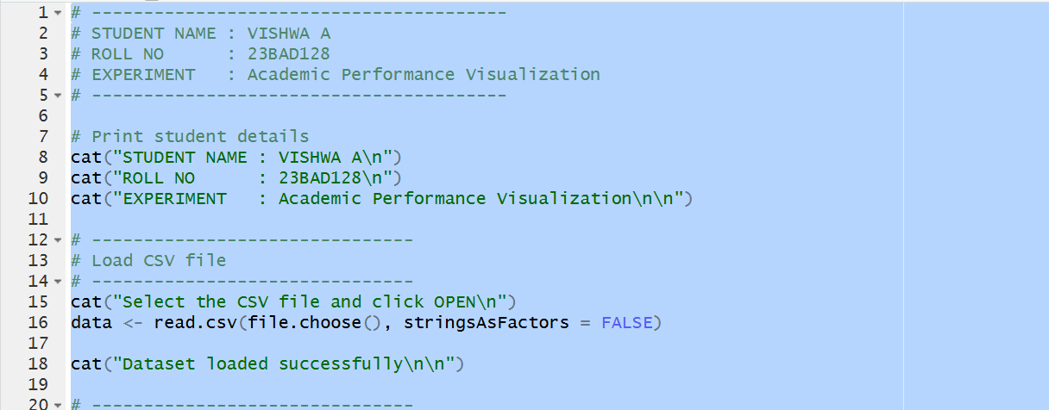
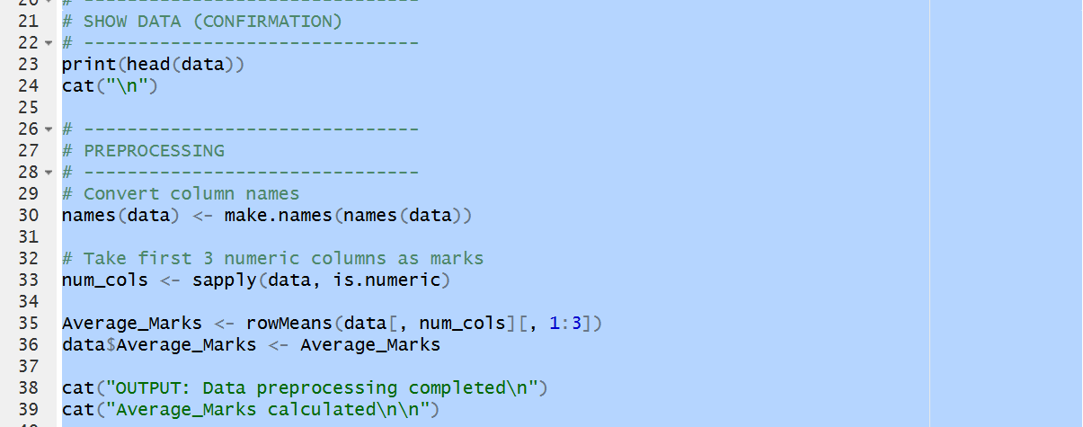
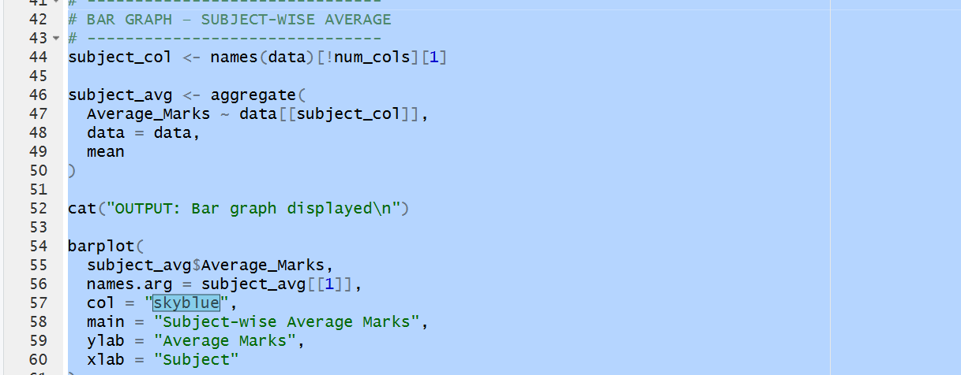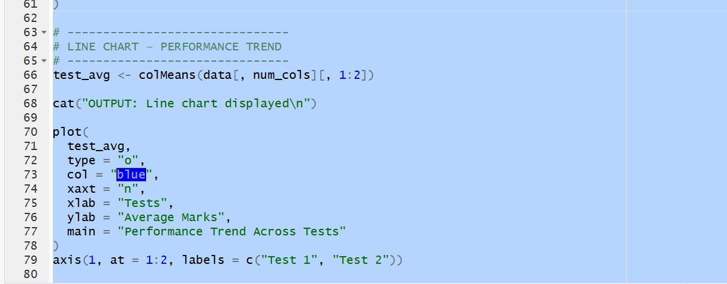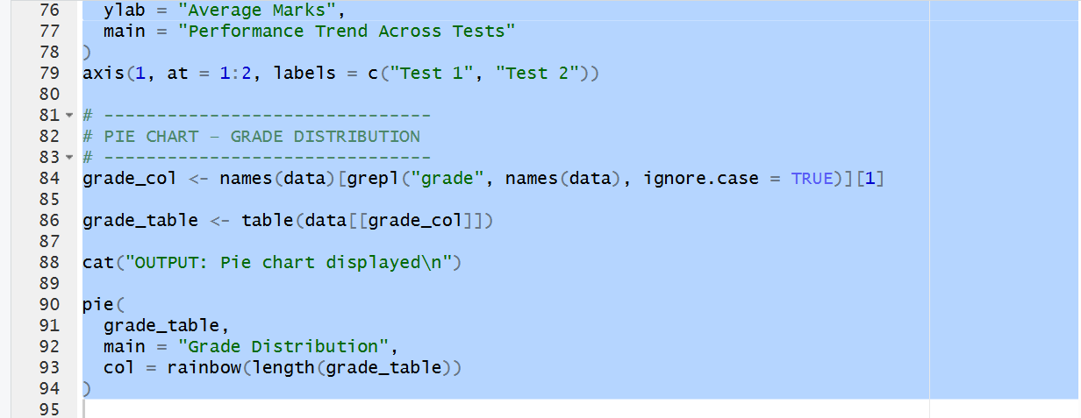 OUTPUT: 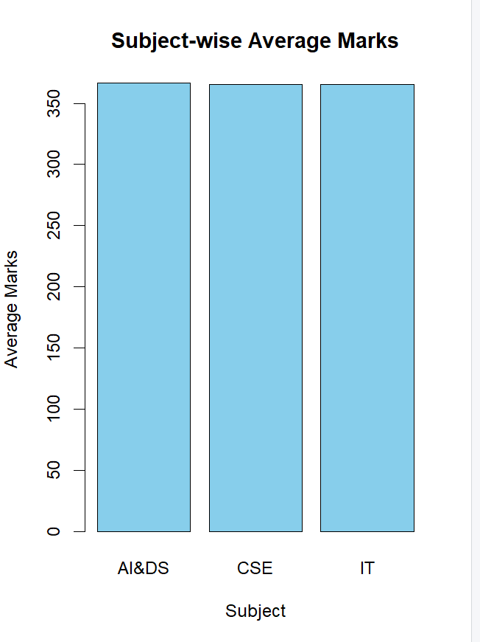
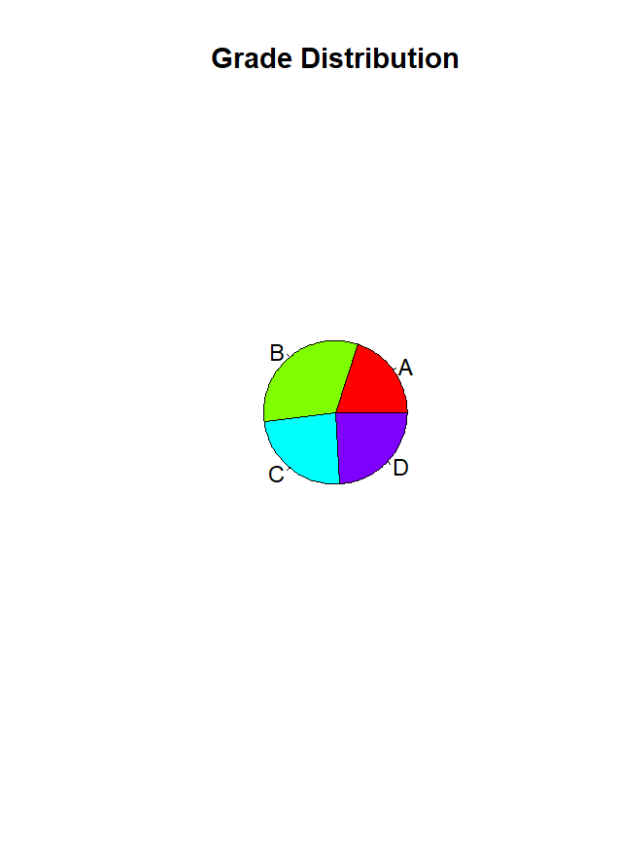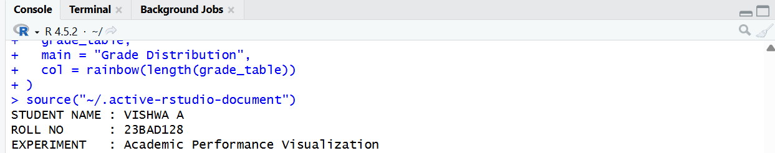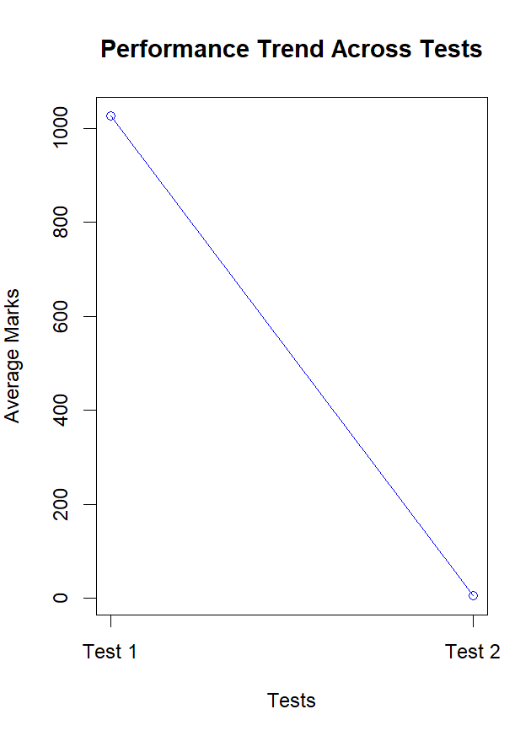
(CODE: CONATAINS STUDENT ROLL NOS
SCREENSHOT OF CODE
SCREENSHOT OF OUTPUT)

POST-LAB QUESTIONS (PROVIDE BRIEF ANSWERS TO THE FOLLOWING QUESTIONS)
- Consistently low-performing subject
DAA, due to the lowest average marks across assessments.
- Why line chart for trends?
It clearly shows changes in performance over sequential tests.
- Limitations of pie charts
Difficult to compare small differences and unsuitable for large datasets.
- Use in curriculum planning
Helps revise difficult subjects, adjust teaching methods, and allocate resources.
- Role in AI-driven academic analytics
Visual outputs can feed ML models for predicting failures and recommending interventions.
ASSESSMENT
Description | Max Marks | Marks Awarded
Pre Lab Exercise | 5
In Lab Exercise | 10
Post Lab Exercise | 5
Viva | 10
Total | 30
Faculty Signature

